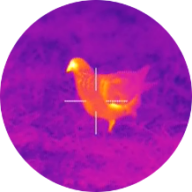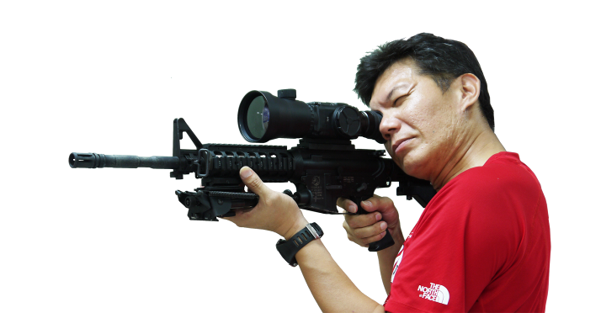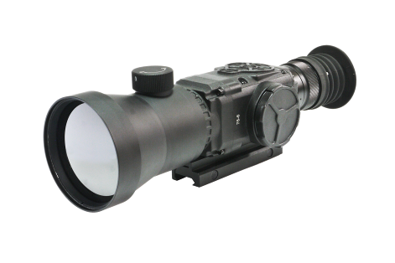

*RAYSUN TS-75*  Thermal Scope



**DESCRIPTION**

* TS-75 uses the latest thermal technology to deliver unrivaled thermal imaging performance. The uncooled thermal detector captures 640x480 resolution and allows to cut through smoke, fog and dust in day or night time.
* TS-75 can detect the infrared energy-heat and allow to find a target hiding in the darkness that conventional image intensified night vision scope can’t .
* The advanced optical system with 75mm objective lens and digital room function makes you can see almost at any range.
* Rich in features of 800 x 600 OLED display, multiple image color modes, adjustable brightness and selectable reticle patterns to optimize the performance
* Support video output and analogy transmission for real-time remote monitoring.
* Built-in 1913 rail enables to mount to weapons or our MD-1 Multicopter Defender.

**SPECIFICATION**

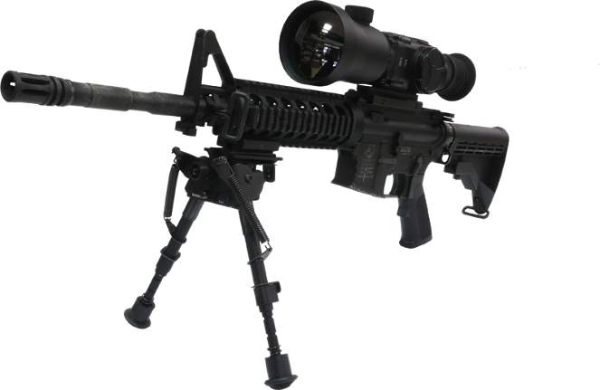

**KEY FEATURES**

|  |  |
| --- | --- |
| Mode | RAYSUN T-75 |
| Type | Uncooled / Infrared ray |
| Sensor (microbolometer) | 640x480 px |
| Material | Amorphous silicon |
| Image Size (output resolution) | 800x600 px |
| Display | Color OLED matrix, SVGA< 800x600 |
| Thermal Sensitivity | <50 mK |
| Lens System | 75 mm |
| Field of View (H x V) | 8.3°x6.2° |
| Eye Relief | 52 mm |
| Optical Magnification | 3.5x |
| Distance of the human detection | 1500 m |
| Distance of the human recognition | 750 m |
| Distance of the human identification | 460 m |
| Reticle pattern | 4 patterns |
| Brightness adjustment | Manual |
| Contrast adjustment | Manual |
| Start up Time | <5s |
| Image palette (color mode) | Color / Black hot / White hot / Green / Blue / Yellow |
| Environmental Rating | Weatherproof / Dust proof /  Shock reduction |
| Battery type | CR123 battery type X4 |
| Battery Life | 2 hrs |
| Mounting bracket | Picatinny rail |
| Low Battery Indicator | Yes |
| Dimension | 300x55x50(mm) |
| N.W. | 1.3kg |
| Warranty | 1 year |

* **4-pattern reticle and variety of image palette as selection**
* **Digital room: 1x, 2x, 4x**
* **Robust body design with shock reduction and weatherproof function.**
* **Use built-in CR123 battery*4 or external power source.**

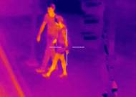

**color**

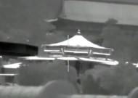

**Black hot (B/W)**

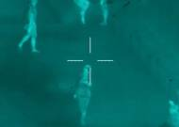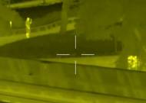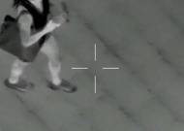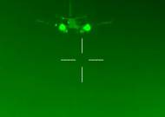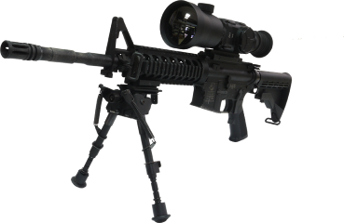

**Yellow**

**White hot (B/W)**

**10**

**Green**

**Blue**

**OPTION:**

* **Touch panel DVR**
* **AV wireless transmitter/ receiver**

**1 TS-75 Thermal Scope**

**2 USB connecting cable**

**3 Video Out/ Power in Cable**

**4 Video / Power Extension cable**

**5 Hard suitcase**

**1**

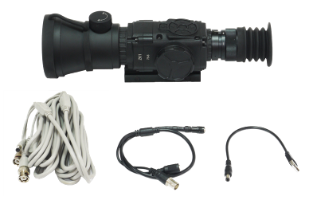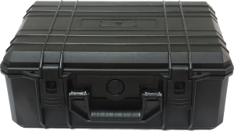

**5**

**4**

**3**

**2**

**戰術滑軌結合強光照明**

**結合雷射瞄準**

